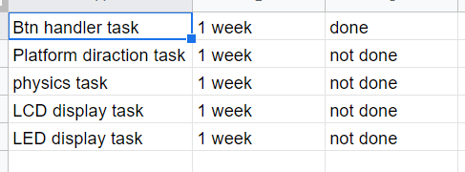

In my expected time, there are five tasks and each will take a week to complete. This week Btn handler task is completed.

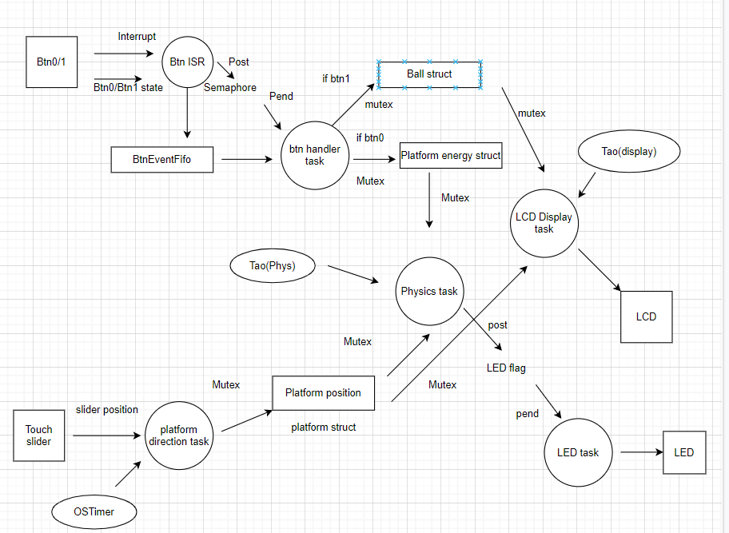

Here is the complete schematic for the project. In order to ensure all the tasks work correctly for the game, there should be 3 unit tests. One is for the Btn handler, another is for the platform direction handler, the last one is for the physics task. For the Btn handler unit test, all I have to check is whether btn0 has successfully set up the energy for the platform and btn1 has successfully removed the ball from the LCD screen.

The platform unit test has 2 things to check. One is to check whether the position in the x direction has changed once the platform hits the wall, the other one is to check that if the left side of the slider is pressed, there will be a force acting on the platform in the left direction but the direction of the platform will not change immediately.

Finally in the physics task, there will be a little more to check. Since the directions of the ball in both x direction and y direction will change. So we have to make sure that the direction of the ball in x direction changes once the ball hits the wall and the direction in y direction changes once it hits the top and the platform whether the platform is energized or not. For the height of the ball after it bounced from the platform, we also need to check if the height is higher than the initial position if the platform is energized, otherwise, the height should gradually decrease. Last thing to make sure is that the ball will bounce up if the ball actually hits the platform instead of the ground.

For this week, Btn handler task for both btn 0 and btn1 is finished. We posted a semaphore inside the btn even irq once the btn0 has been pressed. We add a semaphore pend in the btn0 handler task so that it can set up the energy of the platform after btn0 has been pressed. For btn1, we used the same method, then we added a call to the physics task to remove the ball.

After this week, 20% of the total work has been done. It takes me about 4 days to complete instead of 1 week that I have estimated.

Right now the platform direction task, physics task, LED and LCD task are not finished yet. During the time when I am doing the btn handler task, I first put all of the settings like setting the platform energy in the IRQ handler. Then I realized that this could cause a risk because the btn irq handler has higher priority and if I did all the settings inside the irq handler, that will probably block other important tasks from being executed.